***Make sure, you have saved any unsaved work and quit running applications before following this guide.***

**Windows : Riona Font Installation.**

Download the Riona fonts zip file to a known directory [Like Downloads].

Extract the zip file.

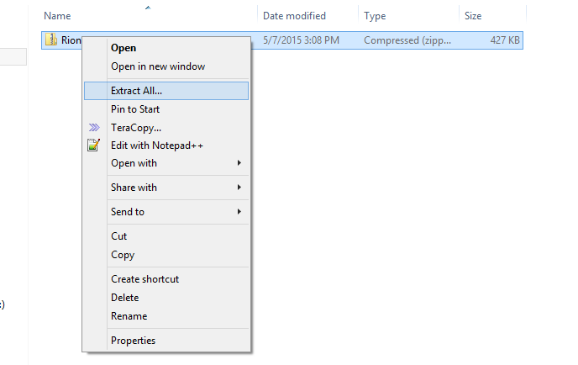

Now navigate to the extracted folder, Select all files inside the folder.

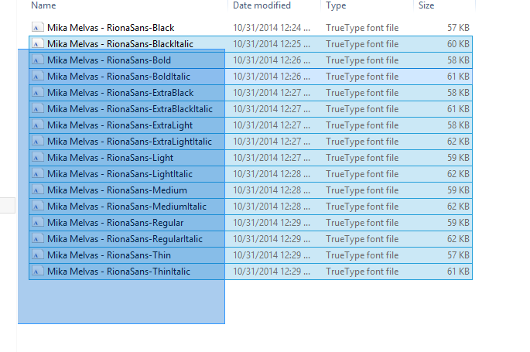

Now right Click and select Install, from the context menu.

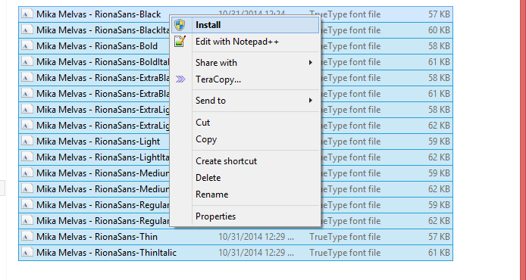

Now you should see the installation progress dialog.

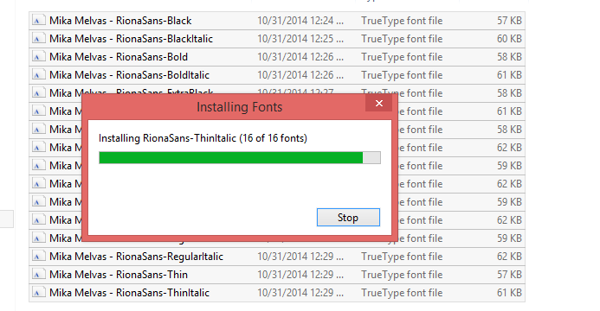

Once it is complete, the newly installed fonts should be available from any program.

Below is the example of notepad.

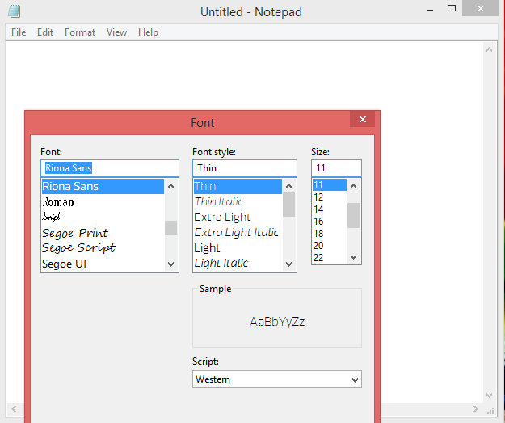

This confirms fonts being installed.

**Mac : Riona Font Installation**

Right click the zip file and select Open to extract the fonts from zip file.

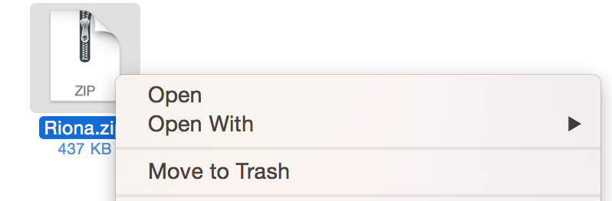

Now navigate to extracted folder and select all the fonts inside the directory.

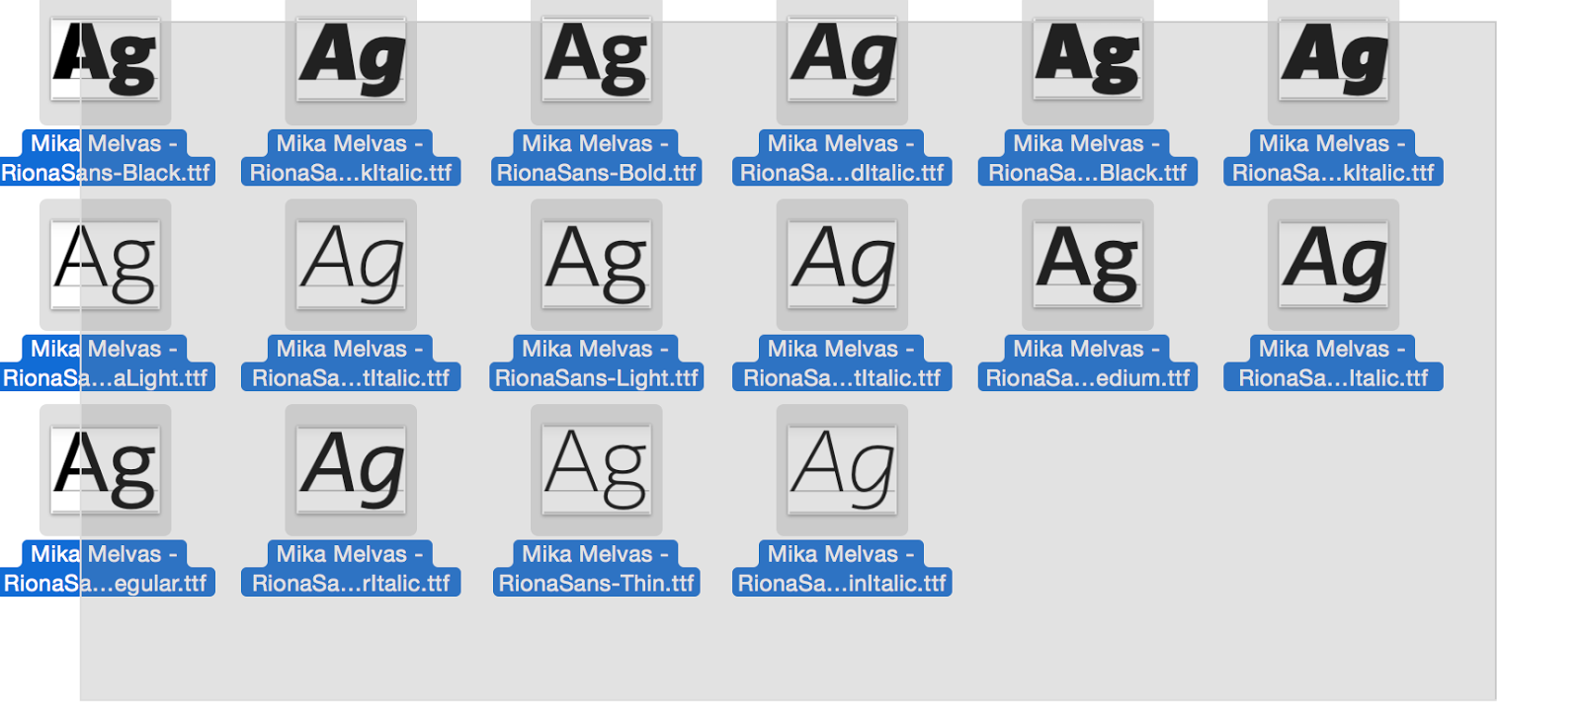

Right click and click copy

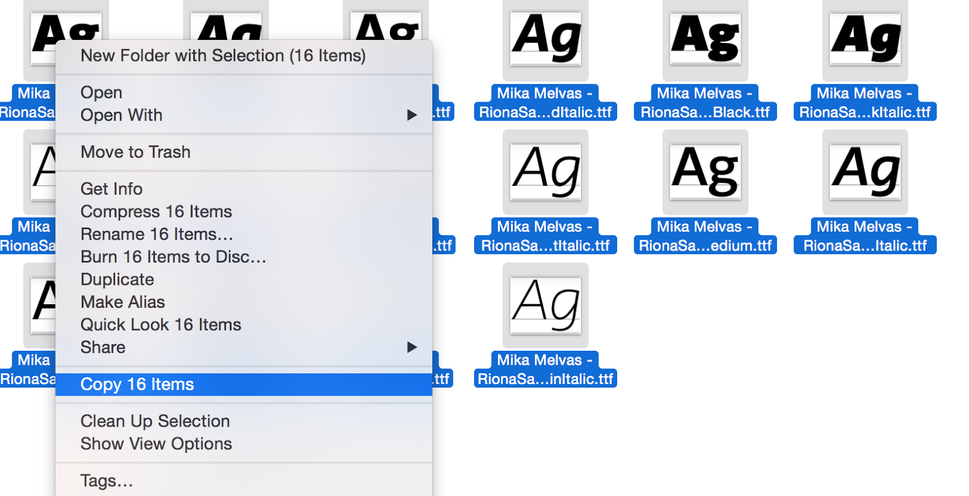

Now select “***Go to folder****”* from Go Menu of Finder.

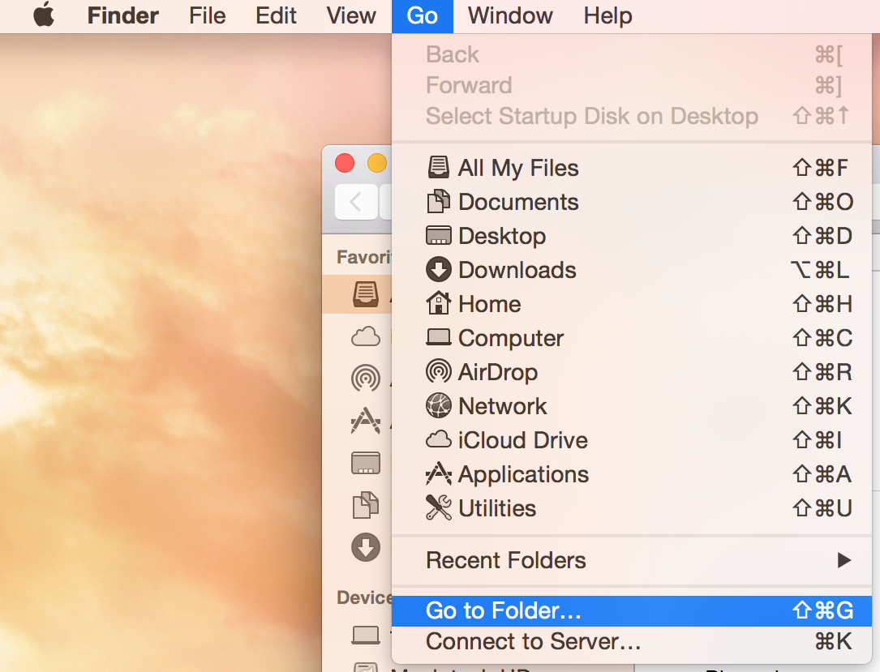

And type ***“/System/Library/Fonts/”*** in the Dialog that appears.

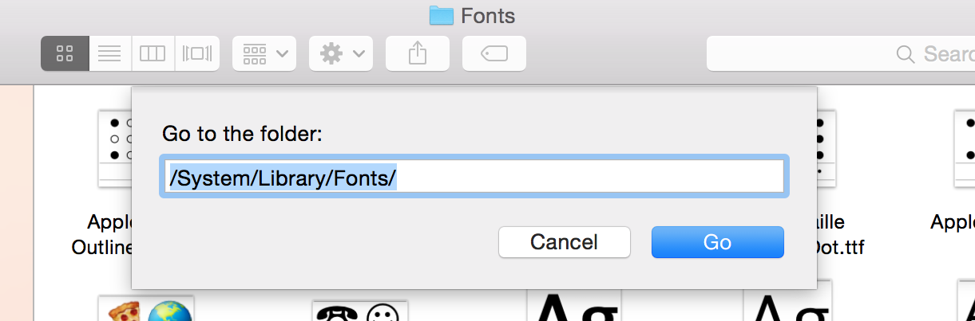

Now right click on empty space and click paste.

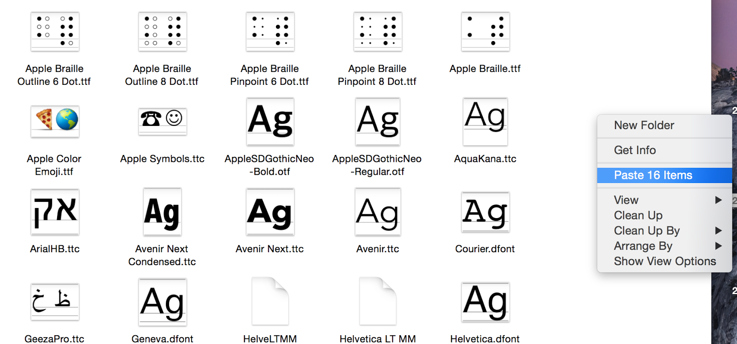

When asked about authentication, enter your account details.

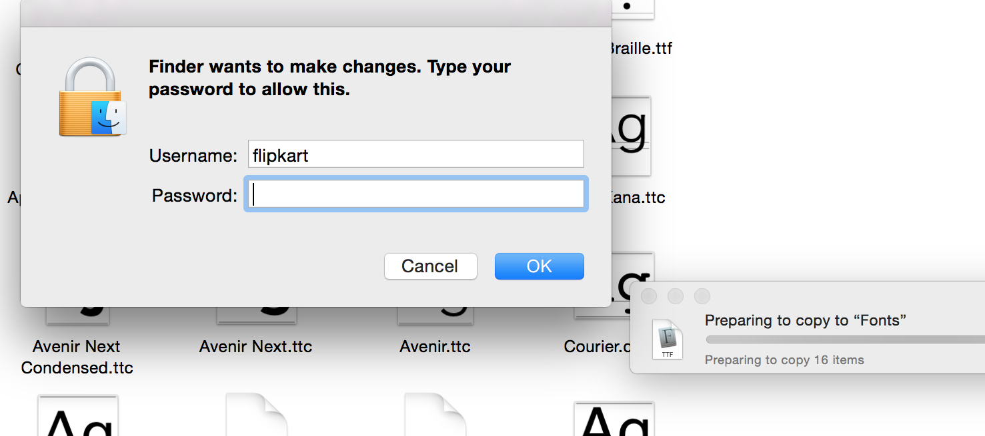

Once the copy action is completed, you should have new fonts available for your programs. You can test the same from TextEdit program.

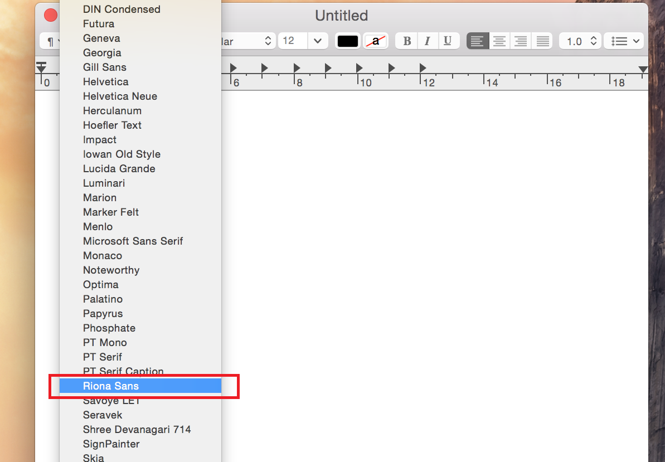

**Linux: Riona Font Installation**

Make sure you have downloaded the font zip file to Downloads folder, then

Hit Windows key to bring up Launcher in ubuntu, and type terminal.

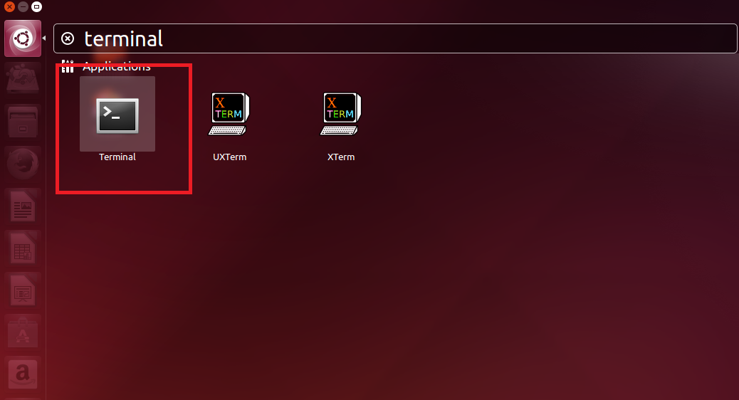

Now in the terminal window, copy paste below commands line by line.

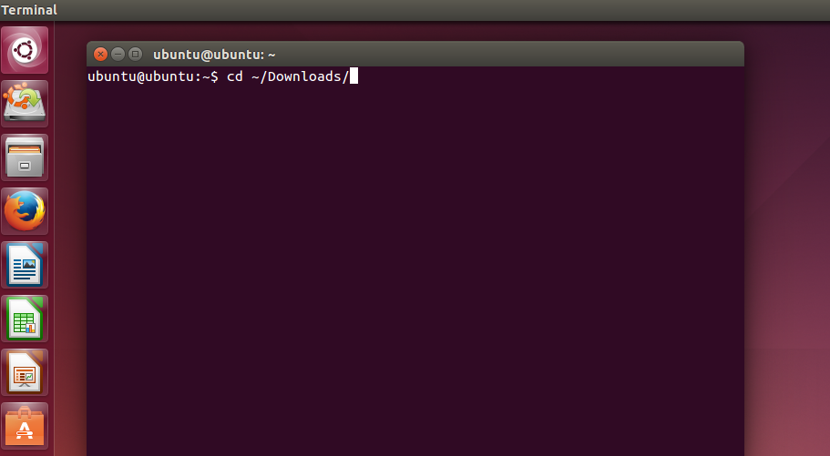

cd ~/Downloads

unzip Riona.zip

sudo cp -Rfv Riona/* /usr/share/fonts/truetype/

sudo fc-cache -v

fc-cache -v

No you should have the new fonts installed.

*if any sudo commands ask for password, enter your system account password.*